《数据库概论》实验一：用SQL进行数据操作 实验报告

吴政亿 151220129 <tel:18805156360> email:18805156360@163.com

实验环境

Windows 10 ，mysql- community-5.7.20.0

实验过程

CREATE DATABASE lab1;

USE lab1;

-- 1.1

CREATE TABLE Student

(

SNO *int* NOT NULL,

SNAME *char*(8) NOT NULL,

SEX *char*(2),

DEPTNO *int*,

PRIMARY KEY (SNO)

);

-- 1.2

CREATE TABLE Course

(

CNO *int* NOT NULL,

CNAME *char*(20),

TNO *int* NOT NULL,

CREDIT *int*,

CONSTRAINT CNO_TNO PRIMARY KEY (CNO,TNO)

);

-- 1.3

CREATE TABLE SC

(

SNO *int* NOT NULL,

CNO *int* NOT NULL,

GRADE *int*,

CONSTRAINT SNO_CNO PRIMARY KEY (SNO,CNO)

);

-- 1.4

CREATE TABLE Teacher

(

TNO *int* NOT NULL,

TNAME *char*(8) NOT NULL,

DEPTNO *int*,

PRIMARY KEY (TNO)

);

-- 1.5

CREATE TABLE Dept

(

DEPTNO *int* NOT NULL,

DNAME *char*(20) NOT NULL,

PRIMARY KEY (DEPTNO)

);

-- 2.1

ALTER TABLE Student

ADD AGE *SMALLINT*;

-- ALTER TABLE Student

-- ALTER COLUMN AGE INT;

-- 这两句话报错 估计是版本不同吧

-- 2.2

ALTER TABLE Student

MODIFY AGE *INT* NULL;

-- 3.1

INSERT INTO Student

VALUES

(1001,'喵喵','m',10,20),

(1002,'汪汪','f',10,21),

(1003,'咩咩','m',10,21),

(1004,'哞哞','f',20,21),

(1005,'呱呱','m',20,22),

(1006,'嘎嘎','f',20,22),

(1007,'咕咕哒','f',30,20);

-- 3.2

INSERT INTO Course

VALUES

(1,'数据结构',101,4),

(2,'数据库',102,4),

(3,'离散数学',103,4),

(4,'C语言程序设计',101,2),

(5,'高等量子力学',105,3);

-- 3.3

INSERT INTO SC

VALUES

(1001,1,80),

(1001,2,85),

(1001,3,78),

(1002,1,72),

(1002,2,82),

(1002,3,86),

(1003,1,92),

(1003,3,90),

(1004,1,87),

(1004,4,90),

(1005,1,85),

(1005,4,92),

(1006,5,99),

(1006,2,100),

(1007,1,80),

(1007,3,91);

-- 3.4

INSERT INTO Teacher

VALUES

(101,'张小天',10),

(102,'胡小伟',10),

(103,'黄程',10),

(104,'郭冰',20),

(105,'钱祺',30);

-- 3.5

INSERT INTO Dept

VALUES

(10,'计算机'),

(20,'信管'),

(30,'物理');

-- 4.1

SELECT *

FROM Student

WHERE SEX = 'f';

-- 4.2

SELECT *

FROM SC

WHERE GRADE BETWEEN 80 AND 89 ORDER BY GRADE;

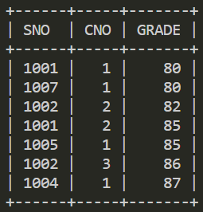

-- 4.3

SELECT DEPTNO,COUNT(1) AS *NUMBER*

FROM Student GROUP BY DEPTNO;

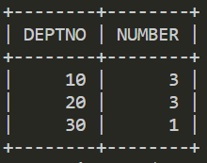

-- 5.1

SELECT Student.SNAME,Student.AGE

FROM Student,Dept

WHERE Student.DEPTNO = Dept.DEPTNO AND Student.AGE <= 21 AND Dept.DNAME = '信管' AND Student.SEX = 'f';

-- 6.1

SELECT SNAME

FROM Student

WHERE SNO != ALL

(

SELECT SC.SNO

FROM SC

LEFT JOIN

(

SELECT Course.CNO, Course.CREDIT

FROM Course,Teacher,Dept

WHERE Course.TNO = Teacher.TNO AND Teacher.DEPTNO = Dept.DEPTNO AND Dept.DNAME = '计算机'

) c

ON SC.CNO = c.CNO

GROUP BY SC.SNO

HAVING SUM(c.CREDIT) >= 5

);

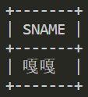

-- 6.2

SELECT Student.SNAME, MAX(GRADE)

FROM Student,SC

WHERE Student.SNO = SC.SNO

GROUP BY CNO;

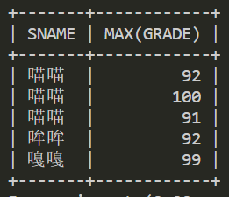

-- 6.3

SELECT DISTINCT SNO

FROM SC SCX

WHERE NOT EXISTS

(

SELECT *

FROM SC SCY

WHERE SCY.SNO = 1007 AND NOT EXISTS

(

SELECT *

FROM SC SCZ

WHERE SCZ.SNO=SCX.SNO AND SCZ.CNO=SCY.CNO

)

);

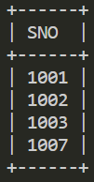

-- 6.4

SELECT DISTINCT SNAME

FROM SC SCX, Student

WHERE Student.SNO=SCX.SNO AND NOT EXISTS

(

SELECT *

FROM SC SCY

WHERE SCY.SNO = 1006 AND EXISTS

(

SELECT *

FROM SC SCZ

WHERE SCZ.SNO=SCX.SNO AND SCZ.CNO=SCY.CNO

)

);

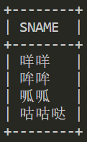

-- 7.1

UPDATE SC

SET GRADE = GRADE + 2

WHERE EXISTS

(

SELECT *

FROM Course

WHERE SC.CNO = Course.CNO AND Course.CNAME = '数据结构'

);

SELECT * FROM SC;

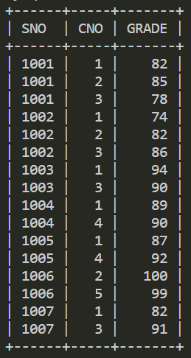

-- 8.1

DELETE FROM SC

WHERE GRADE < 80 AND SNO IN

(

SELECT SNO

FROM Student

WHERE SEX = 'f'

);

-- 9.1

CREATE VIEW CS_STUDENT AS

SELECT SNO, SNAME, SEX

FROM Student,Dept

WHERE Student.DEPTNO = Dept.DEPTNO AND Dept.DNAME = '计算机';

SELECT * FROM CS_STUDENT;

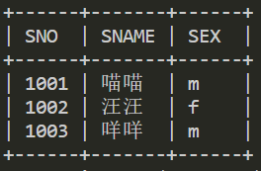

-- 9.2

DROP VIEW CS_STUDENT;

-- 10.1

DROP TABLE Student;

-- 10.2

DROP TABLE Course;

-- 10.3

DROP TABLE SC;

-- 10.4

DROP TABLE Teacher;

-- 10.5

DROP TABLE Dept;

DROP DATABASE LAB1;

实验中遇到的困难及解决办法

为什么书上的语法不对……

尝试了几款SQL软件最后选择了MySQL，因为我们的SQL都是基于命令的所以也建议以后的教学把机房的SQL Server换成MySQL。

参考文献及致谢

http://www.w3school.com.cn/sql/index.asp

这个网页教程很全啊